Luminous Onion User Guide

|  |  |
| --- | --- |
| Project Location: | <https://gitlab.com/wgu-gitlab-environment/student-repos/zkarpi1/d424-software-engineering-capstone/-/tree/v1> |

Contents

Getting Started 2

Prerequisites 2

Accessing Web Application 2

Basic Structure 2

Home Screen 2

Products 4

Adding a product 4

Managing a product 5

Adding a source to a product 6

Viewing product findings 7

Deleting a product 8

Sources 10

Adding a new source 10

Deleting a source 11

Basic Reporting 13

Group By Package 13

Group By Severity 13

Group by Product & Severity 14

Group by Product & Package 14

# Getting Started

## Prerequisites

This guide assumes you’ve already setup and have access to a working application. If not, please see the Build and Setup guide.

## Accessing Web Application

By default, the URL should be <http://localhost:8081>, but check the correct URL and port from the setup or your administrator.

Once you navigate to the web application URL, you will be greeted the home screen.

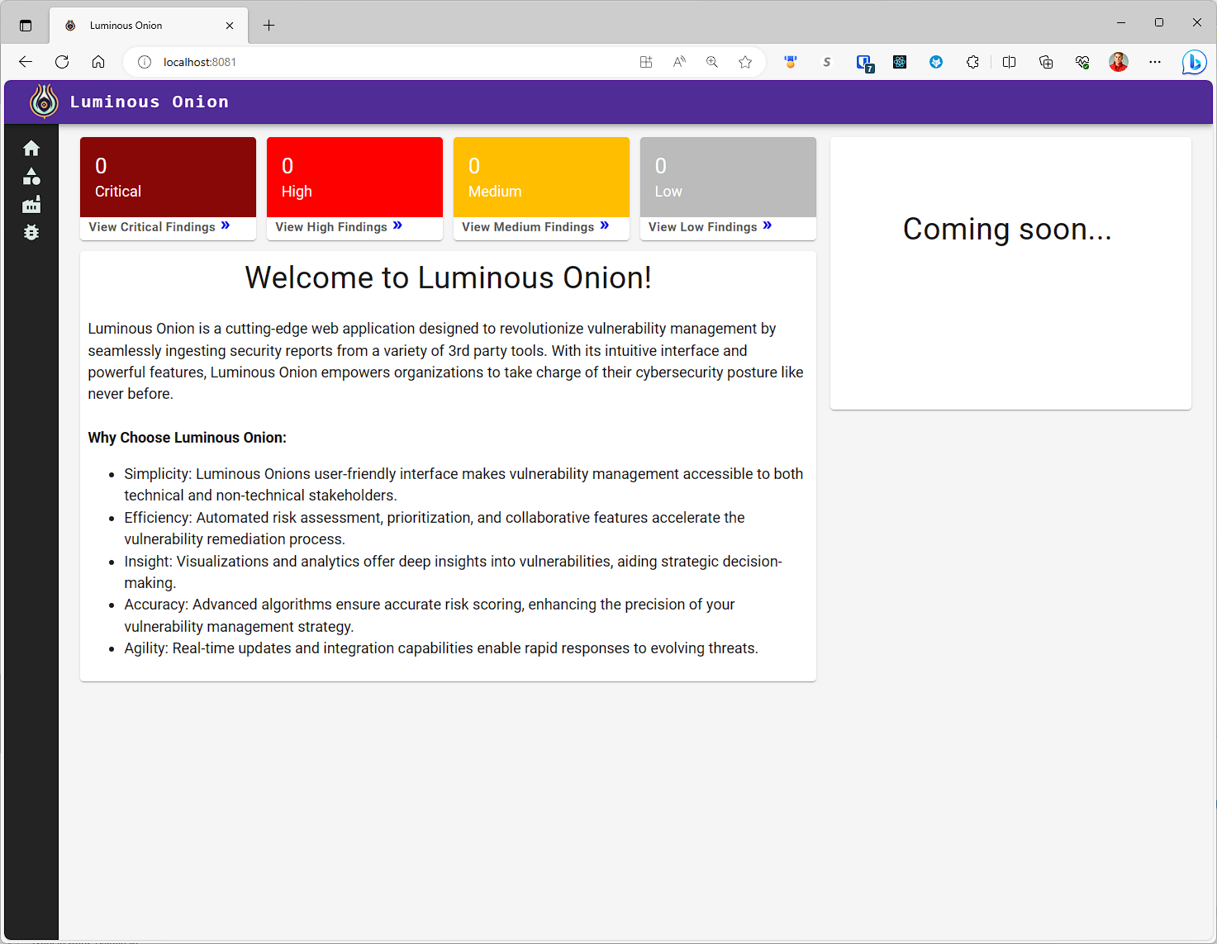

The rest of the guide will explain how to use the application and guide you through uploading and reviewing a test product.

## Basic Structure

Luminous Onion is used to manage vulnerabilities found in products. Each product may have multiple sources which contain findings. These sources are from different popular 3rd party tools such as Snyk, Grype or Trivy. Below, we’ll review each page.

## Home Screen

The home screen contains a **summary card (#1)** which provides the overall findings of all products by severity. Once you complete the guide below, this will be populated in your instance. On the left side is a **nav bar** which contains buttons to navigate to the various screens.

* Home (#2)
* Products (#3)
* Sources (#4)
* Findings (#5)

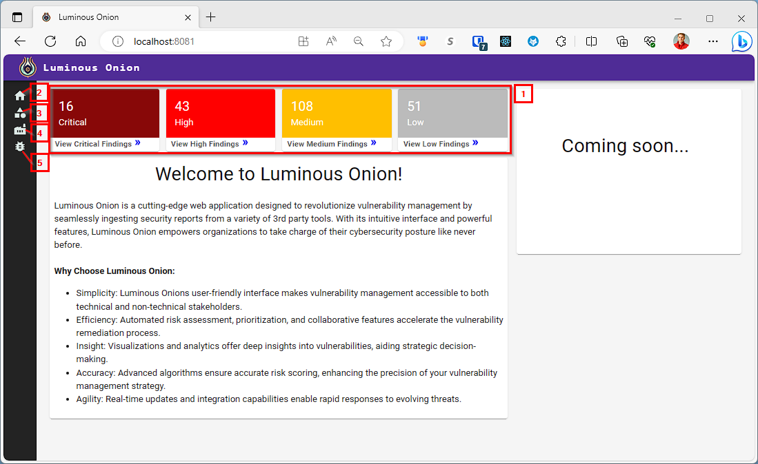

# Products

Products are the top-level entity that present a product developed or maintained by your organization.

## Adding a product

To create a new product, first navigate to the **Products** page by clicking Products on the left nav then click **Create** on the top left of Products page which will display a **Create new product** popup window. Finally, enter a required **Product Name** and the optional details below and click the Create button at the bottom of the window to finalize creating your new product. Once you **refresh** the products page, your new product will be listed.

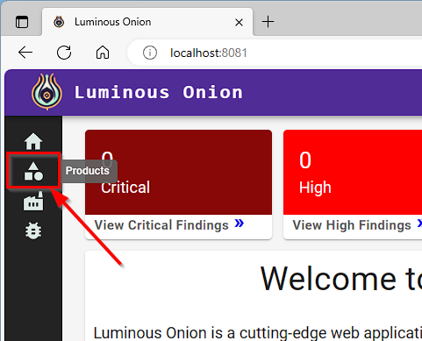

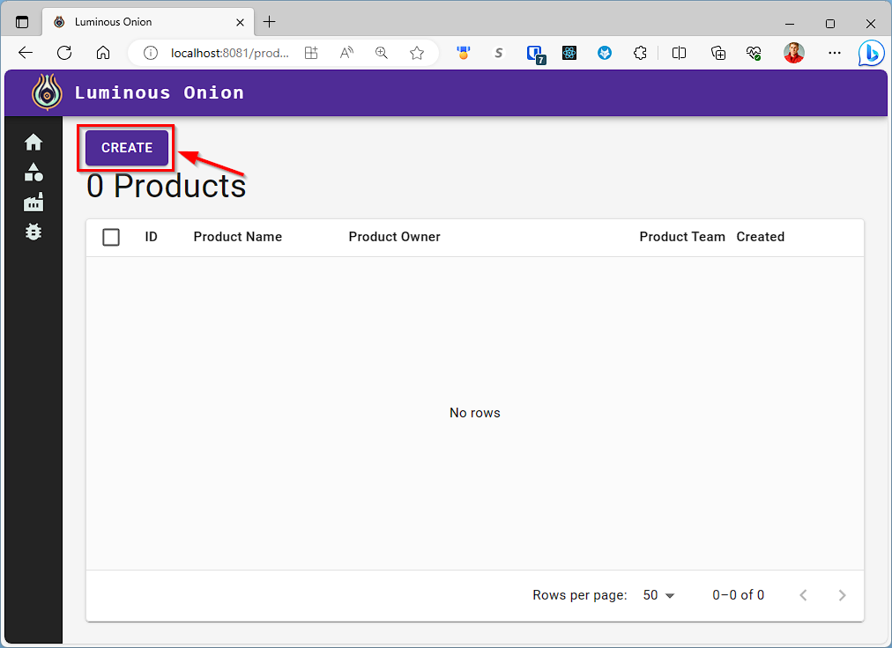

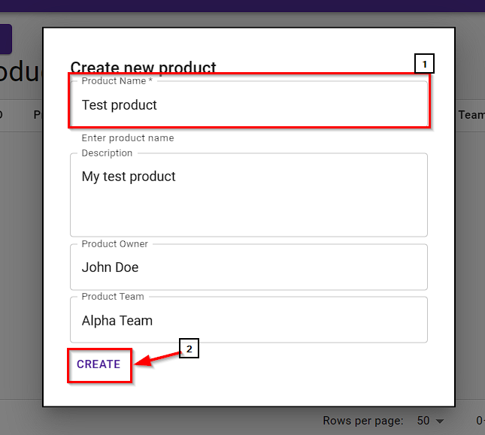 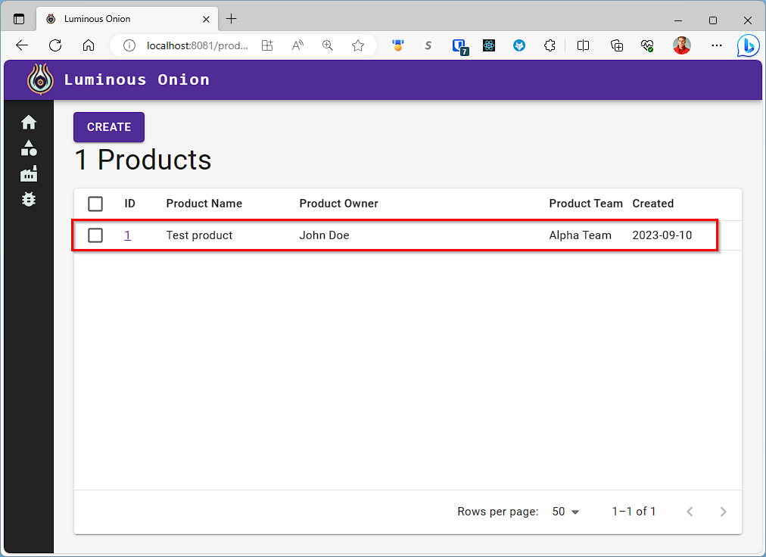

## Managing a product

Once a product is created, click the **ID** number to view the product. From the product page, there are several features. At the top lists the **total findings by severity** for the entire product. Below, there are tabs to navigate to the **overview** page, **findings** page and **settings** page. Next, we have the **product details** Finally, there is a **sources section** listing all the sources and their respective findings. From this section, you can add new sources. Let’s do that now.

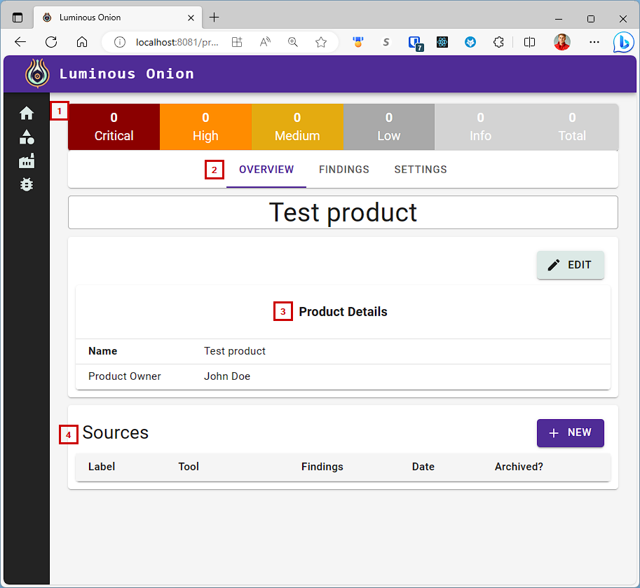

### Adding a source to a product

On a product view page, select **New** from the Sources section.Next enter the required **label**, **source type** and **upload file**. Notice how product is prepopulated to the product you have open. Finally enter **details** and select if you’d like to **archive** the previous results from the same source. For a demo file, use the **webgoat-trivy.json** file located in root/examples/samples folder or [download it here from GitHub](https://github.com/zkarpinski/Luminous-Onion/blob/56c66248111120e9a035fd015cf7225ad8c7ebf8/examples/samples/webgoat-trivy.json) and select **Trivy** as your source type. Finally click **Submit** to upload your source. The backend will analyze the results. **Refresh your product page** to view the new source and the findings summary.

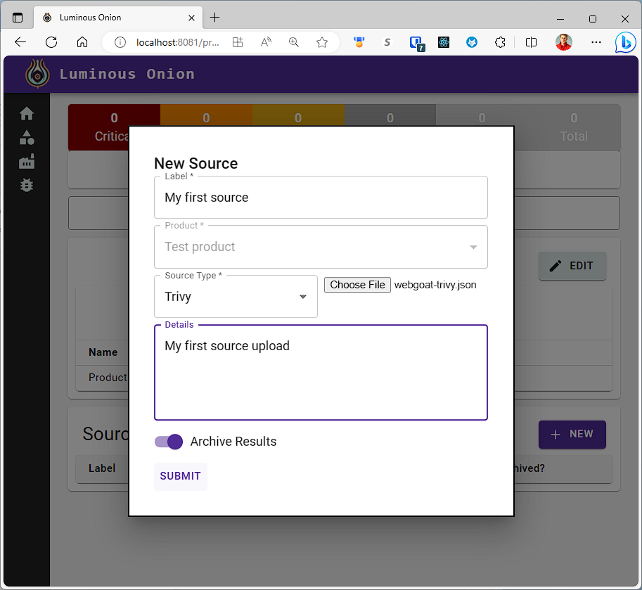 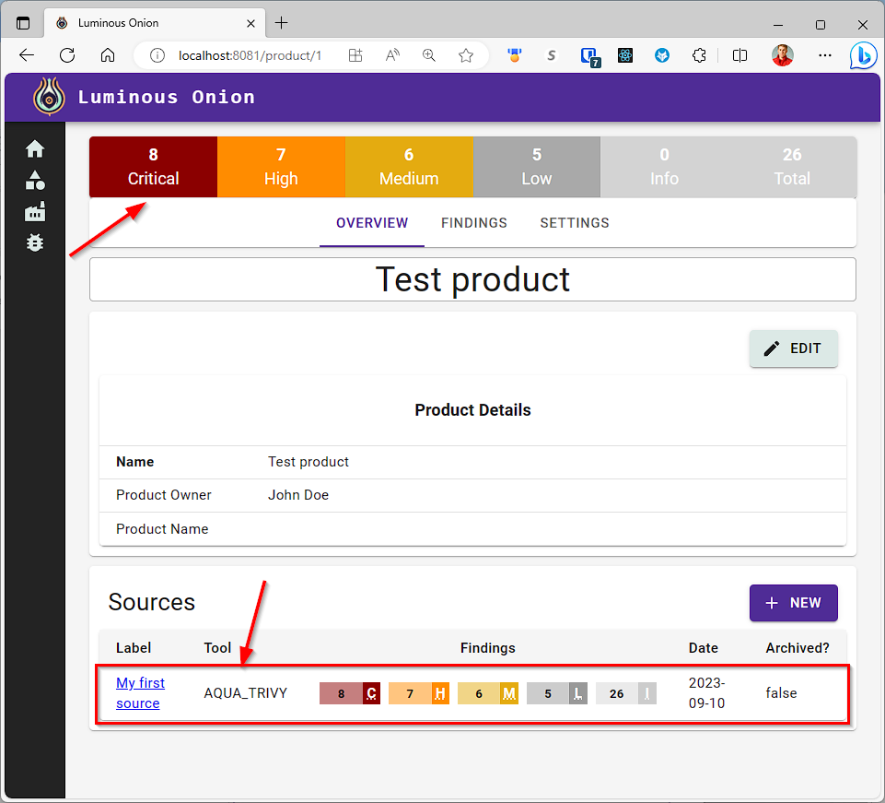

### Viewing product findings

To review the product findings, navigate to the **Findings tab** on the product view screen. One this screen you can sort by severity, created date and any column visible. You can also search by entering a value in the **search bar**.

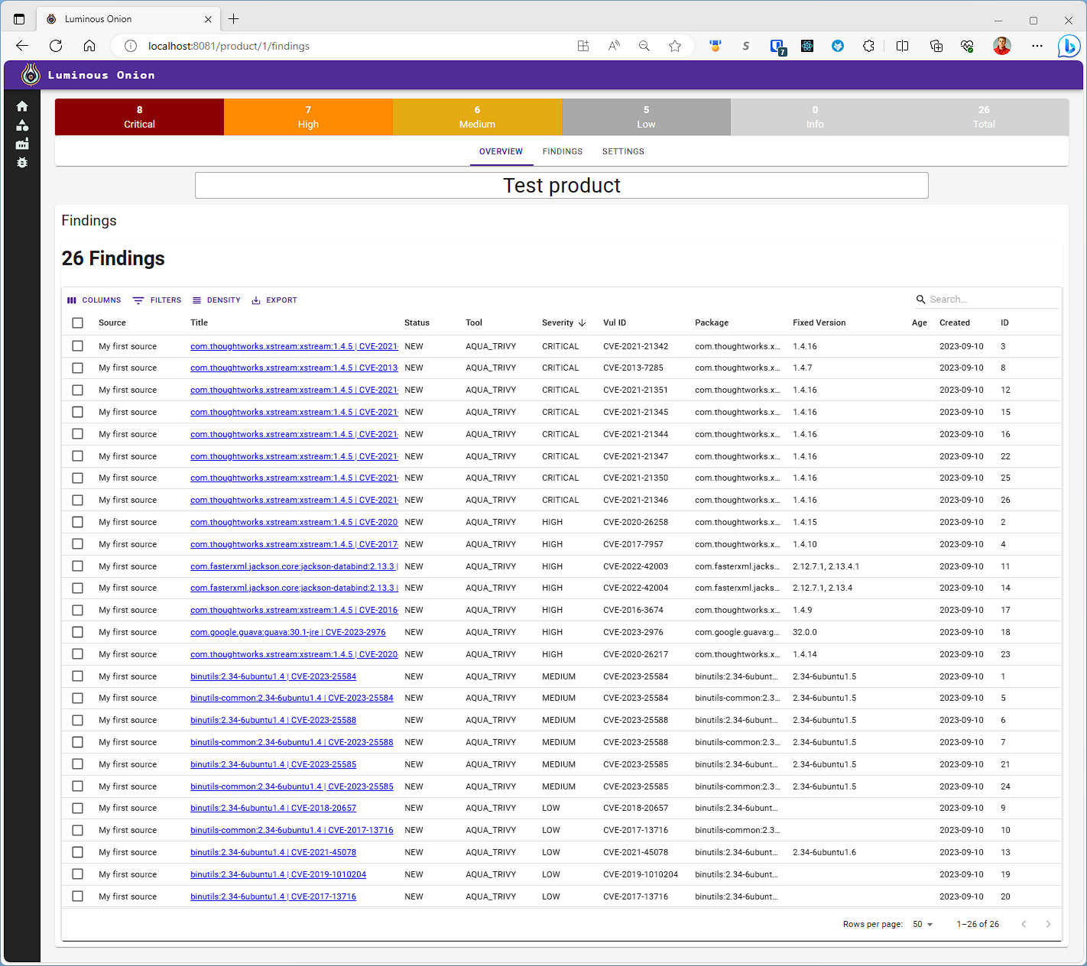 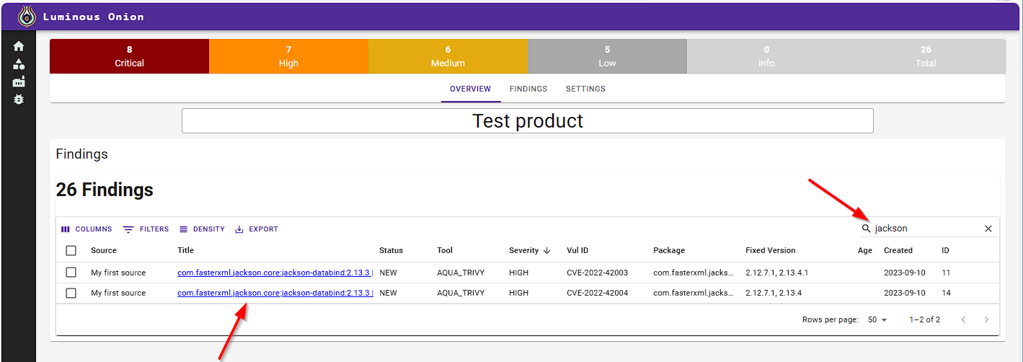

### Deleting a product

To delete a product, navigate to the **Settings** tab. Click the **DELETE PRODUCT** button and confirm the deletion by click **Yes** on the popup.

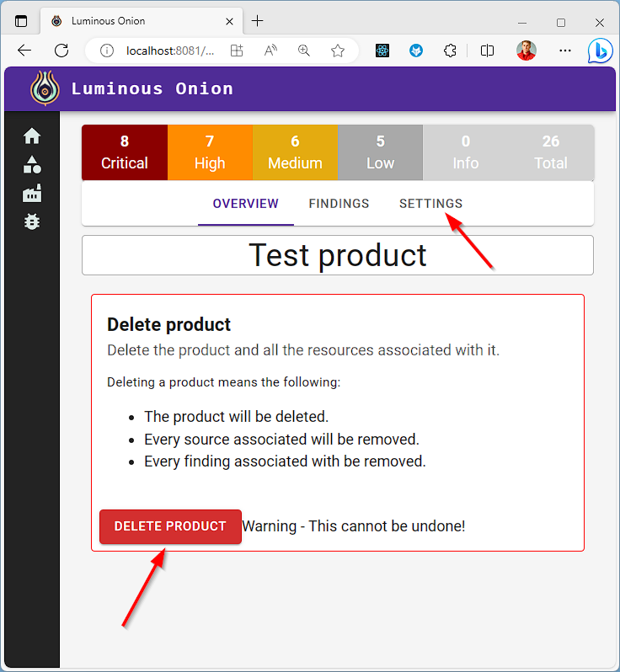 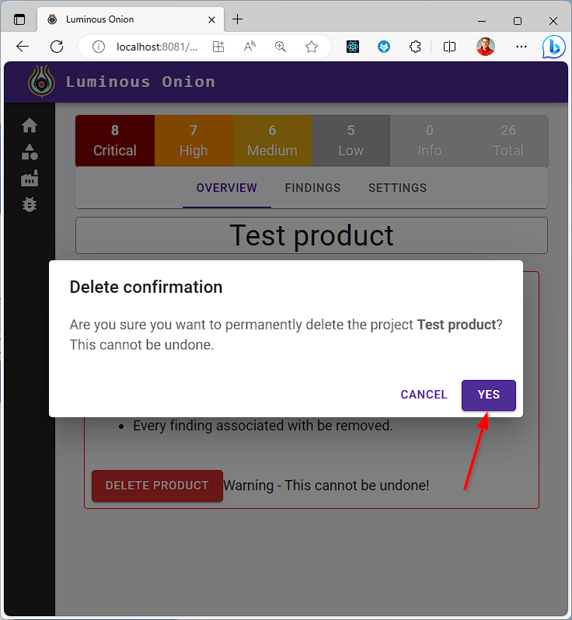

# Sources

Sources are files uploaded by users tied to a specific product. Each source may have 1 or more findings associated to it. Typically, you will review sources under the product page but in certain scenarios, it may be useful to view all the sources. To do this navigate to the sources page. One this page you can view existing sources, add a new source or delete an existing source.

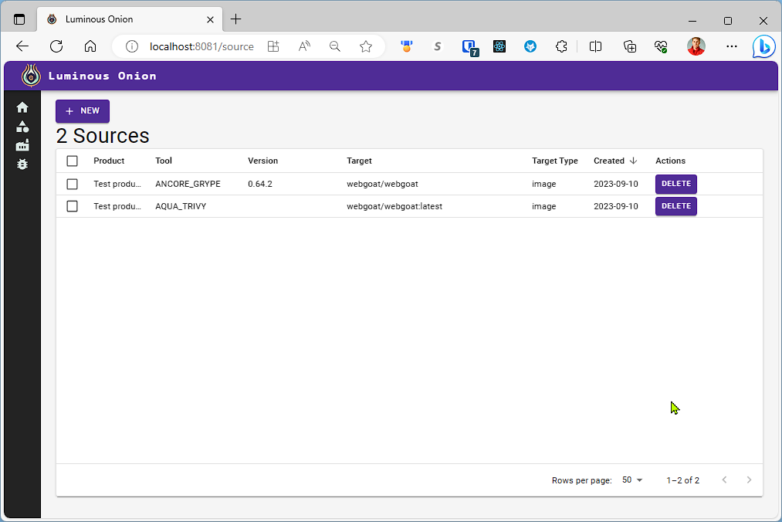

## Adding a new source

On the sources page, click the New button to open the new sources window. Next, populate the required Label, Product, Source Type and Source file. Note how product is not prepopulated this time. For this example, you can use the example **webgoat-grype.json** file located in *root/examples/samples folder* or [download here on GitHub](https://github.com/zkarpinski/Luminous-Onion/blob/b067bb8b050a13fd4d9975bef77ba1bda8740415/examples/samples/webgoat-grype.json). Finally click submit to create the new source and refresh the sources page to view the addition.

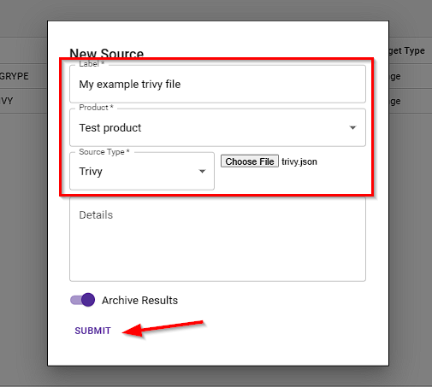

## Deleting a source

Sometimes it may be required to delete a source. On the sources page, simply click the **Delete** action for the source you wish to delete and click **Yes** on the confirmation screen.

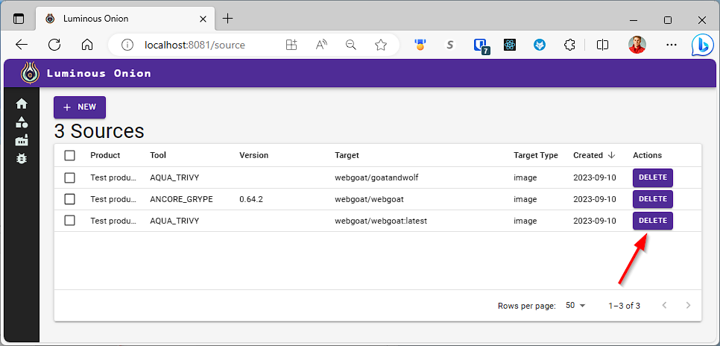

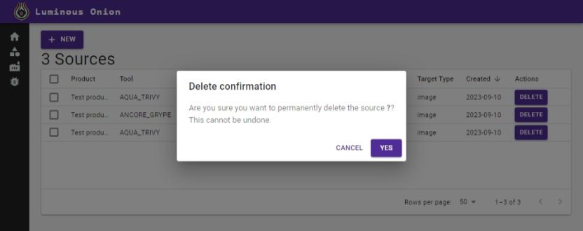

# Basic Reporting

Reporting is an essential part taking action on these findings. Luminous Onion has some pre-configured reporting capabilities. First, navigate to the findings page on by selecting Findings on the left nav bar. From here, you can filter and group the findings based on different options. Each have a specialized purpose in order to take action. In each grouping, you can expand to view the details.

### Group By Package

This view gives you the total findings per package, showing which packages impact your product(s) the most to take action on. You can

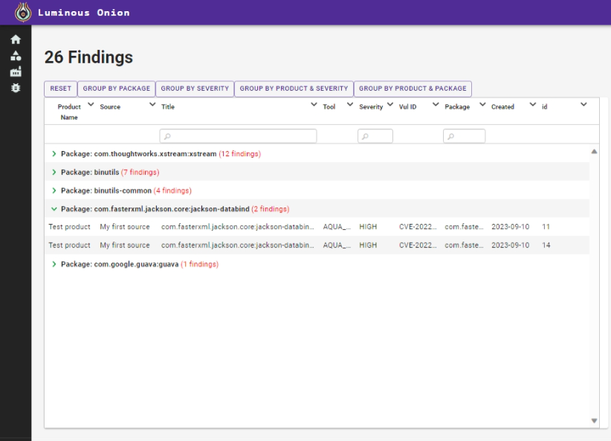

### Group By Severity

This view gives you the total findings per severity level across all products. Use this to take action on the highest severity findings first.

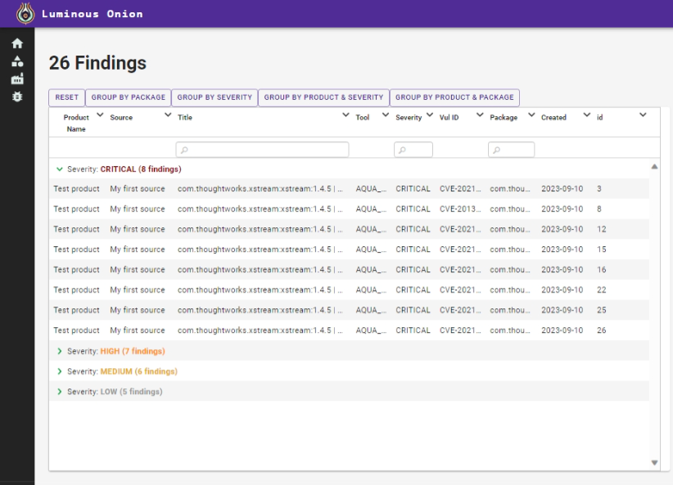

### Group by Product & Severity

This view gives you the total findings per severity level by product. Use this to take action on the highest severity findings by product. Notice we added an additional product in the example below.

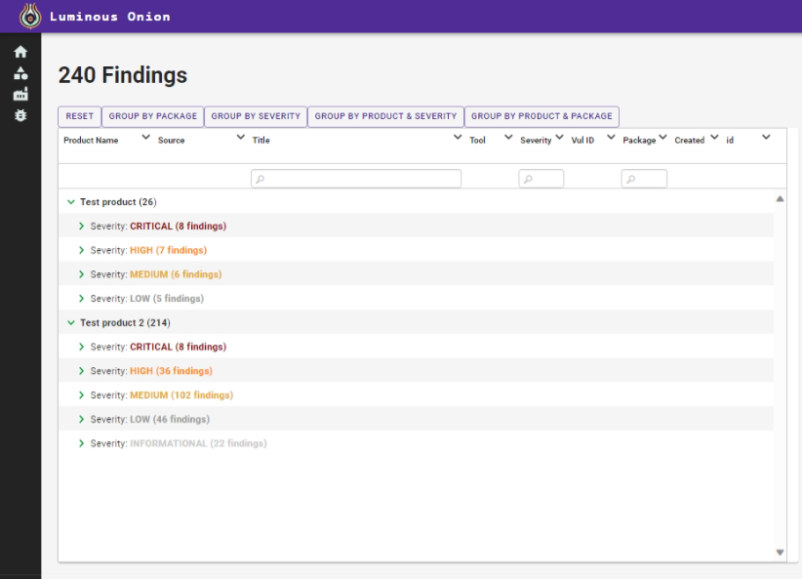

### Group by Product & Package

This view gives you the total findings by product and package. Use this to take action on packages with the most findings across all products or a given product.

